Lab 3: Ancient Algorithms
CSC 340: Applied Combinatorics

Background

Prime numbers play a critical role in encryption algorithms. Public-key cryptographic systems, such as RSA, rely on the difficulty of factoring the product of two large prime numbers. The security of these systems is based on the following: it is easy to multiply large prime numbers together, however it is extremely difficult to factor the resulting product back into its prime components.

The RSA public-key cryptosystem system was developed in 1977 by Ron Rivest, Adi Shamir and Leonard Adleman. However, the concept of finding prime numbers dates back to ancient times. In this lab, you will experiment with different ancient algorithms for finding prime numbers. Eratosthenes of Cyrene developed a way to determine the first $n$ prime numbers in the 3rd century. The steps are as follows:

Step 1: Given $n$, write out all the integers from 2 to $n$.
Step 2: Cross out all multiples of 2, except for 2 itself. Let us denote this as having “tested” 2. Next go to 3 and test 3 by crossing out all multiples of 3 in the list except 3 itself.
Step 3: Repeat the process in step 2 for every number in the list that has not been tested or crossed out.
An example of this “ancient” algorithm for $n=30$ is given below:
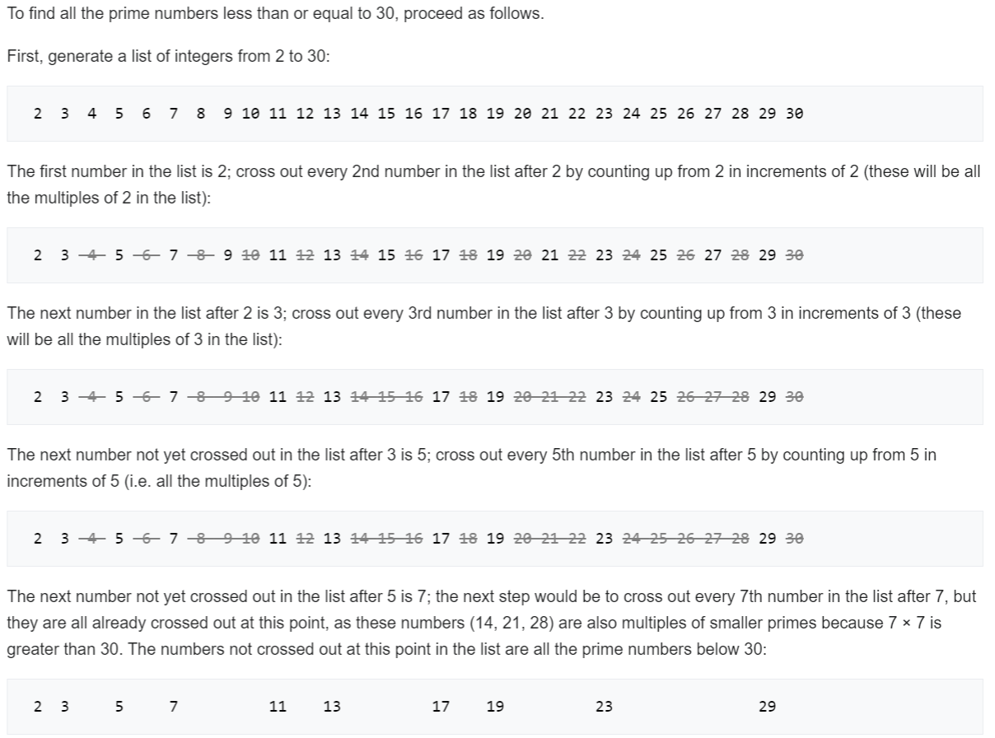
Figure Source: https://en.wikipedia.org/wiki/Sieve_of_Eratosthenes

Lab Assignment
Exercise 1: On an ancient tablet in Greece, we have recovered part of the Python code Eratosthenes originally wrote for his sieve code for finding prime numbers.
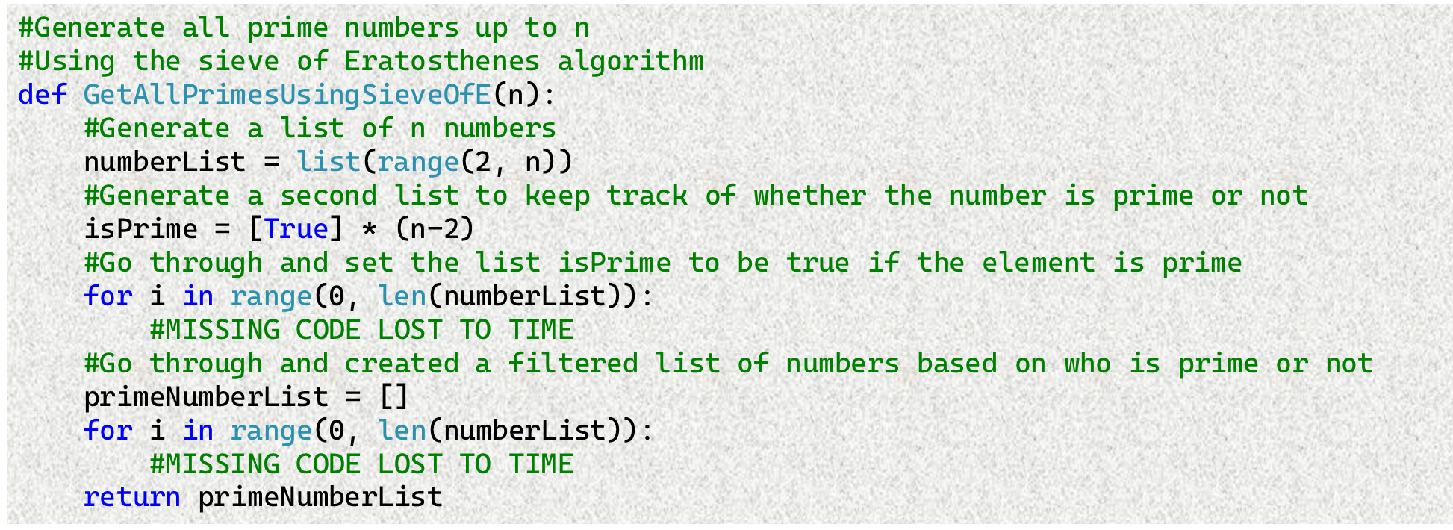
Exercise 1: Part A: Fill in the missing pieces in the skeleton code provided above. Hint: You can test your code with $n=30$ and check if the code is correct by looking at the example given in the background section. After completing the code, use it to find all the primes numbers up to 100?

Exercise 2: Another theorem to test for prime numbers was first discovered by Ibn al-Haytham in c. 1000 A.D. (proven by John Wilson in 1770). The test for prime numbers using Wilson’s theorem is as follows: any integer n > 1 is a prime number if, and only if, (n − 1)! + 1 is divisible by n. Luckily, we discovered another old Python code for this algorithm from John Wilson’s notes. However, once again pieces of the algorithm have been lost to history:
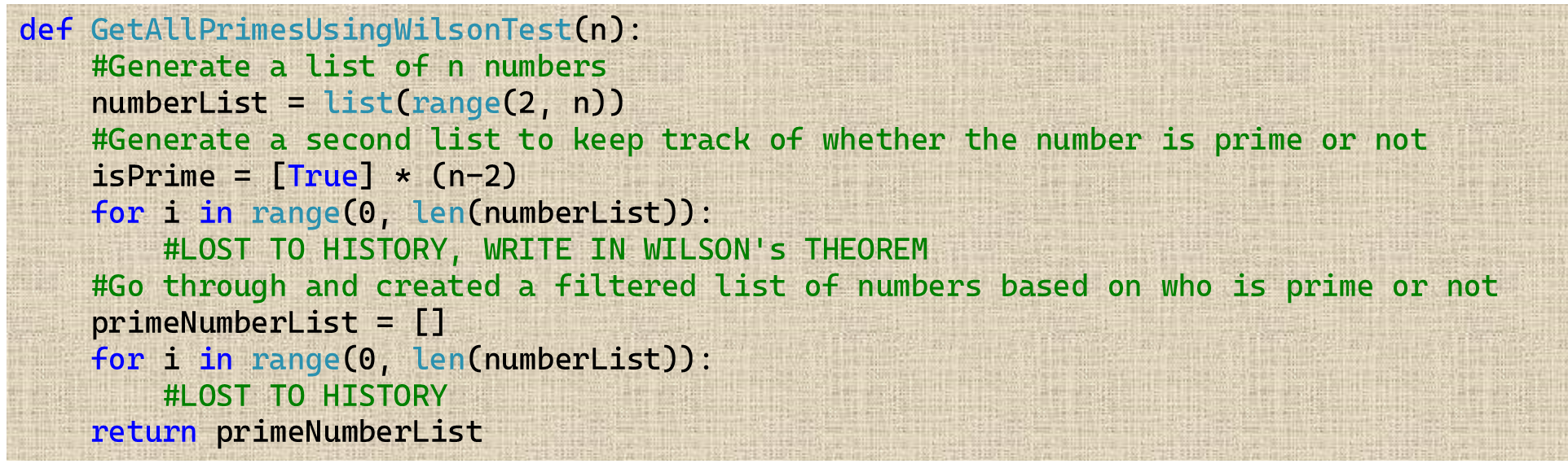
Exercise 2: Part A: Fill in the missing pieces of Wilson’s Theorem for testing for prime numbers in the skeleton code provided above. What values does the code produce when $n=30$? Is this an efficient way to test for prime numbers?
Exercise 3: The computational complexity of the first two algorithms is an issue. Fermat came up a faster way to test for prime numbers in the 1600s, probably because his computer was running these algorithms too slowly. The pseudo-code for the algorithm is as follows:
Input: $q$ an integer to test for primality. $q>3$. $K$ a set of integers to test $q$ between 2 and $q-2$.
Output: Composite if $q$ is composite. Otherwise return prime.
For each $k$ integers in set $K$:
If $k^{q-1}-1$ is not divisible by $q$ return False (not prime) and stop.
If for loop finishes without stopping: Return True (prime).
Exercise 3 Part A: Write a function called “FermatTestForPrime” that takes in an integer $q$, a list of integers $K$ to test with and returns either true or false. Note this algorithm is non-deterministic meaning it may not work depending on what values you give it for $q$ and $K$. Try it $q=221$ and $K=[2, 24]$, what does the code produce? What about if $q=221$ and $K=[38]$? Is $q=221$ prime or composite?

